2017 EACTS Guidelines on perioperative medication in adult cardiac surgery
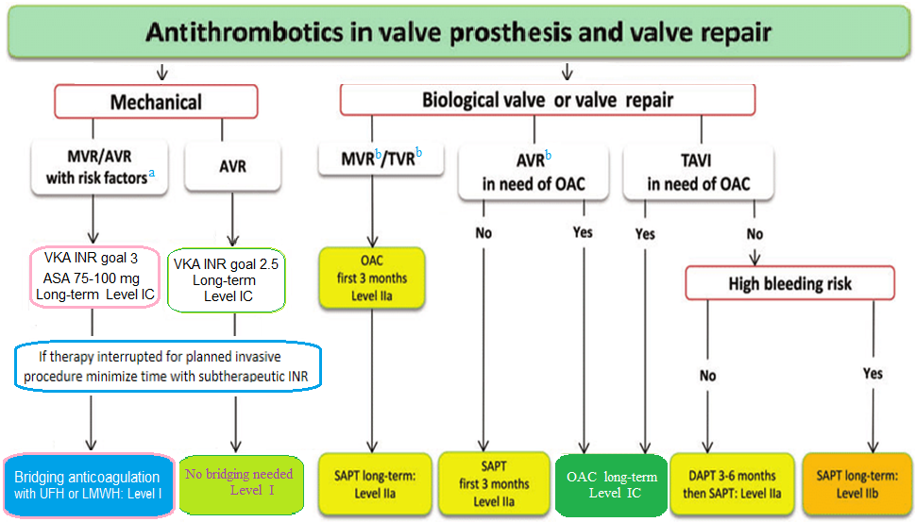
a Includes atrial fibrillation, previous thromboembolic events, left ventricular dysfunction and older generation mechanical AVR; b stands for replacement or repair. See next page for TAVR new recom.
ASA: acetylsalicylic acid; AVR: aortic valve replacement; DAPT: dual antiplatelet therapy; INR: international normalized ratio; LMWH: low-molecular-weight heparin; MVR: mitral valve replacement; OAC: oral anticoagulant; SAPT: single antiplatelet therapy; TAVI: transcatheter aortic valve implantation; TVR: tricuspid valve replacement; UFH: unfractionated heparin; VKA: vitamin-K antagonists.

Antithrombotic therapy post-TAVI UpToDate 2024

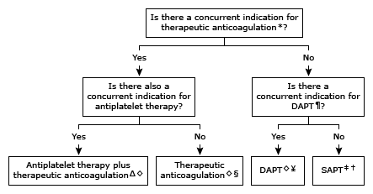

TAVI: transcatheter aortic valve implantation; DAPT: dual antiplatelet therapy; SAPT: single antiplatelet therapy; VKA: vitamin K antagonist; DOAC: direct oral anticoagulant.
* Therapeutic anticoagulation does not include low-dose heparin therapy for prophylaxis against venous thromboembolic disease. The most common concurrent indication for therapeutic anticoagulation post-TAVI is atrial fibrillation with risk factors favoring anticoagulation (eg, CHA₂DS₂-VASc score ≥2). The choice and duration of anticoagulant therapy is based upon the indication for anticoagulation.
¶ Common indications for DAPT include recent coronary stent implantation and recent acute coronary syndrome.
Δ The choice and duration of antiplatelet and anticoagulant therapy are based upon the indications for these agents. Long-term triple antithrombotic therapy (dual antiplatelet therapy plus anticoagulation) is generally avoided given evidence suggesting worse outcomes compared with dual antithrombotic therapy.
◊ When a patient no longer requires anticoagulation or DAPT, then SAPT is used.
§ Antiplatelet therapy is not required in this setting. During the first 3 months post-TAVI, VKA is the preferred anticoagulant. After the first 3 months, the choice of anticoagulant (VKA or DOAC) is based upon the indication for anticoagulation and other clinical factors.
¥ DAPT consists of aspirin 75 to 100 mg daily plus clopidogrel 75 mg daily. No loading dose is required for aspirin therapy. Clopidogrel is initiated as a 300 mg loading dose followed by a 75 mg daily maintenance dose.
‡ In this setting, SAPT is generally aspirin 75 to 100 mg daily. If aspirin is contraindicated due to hypersensitivity, clopidogrel is an alternative.
† A reasonable alternative is to use DAPT in the intermediate term (during the initial 3 to 6 months depending upon valve type) followed by lifelong SAPT, which is the approach used in the pivotal TAVI trials. If intermediate-term DAPT is chosen, it is continued for the first 6 months (for the SAPIEN valve) or for the first 3 months (for the Evolut R/PRO/PRO-PLUS valve).

Patients with concomitant atrial fibrillation
Valvular atrial fibrillation is always considered a high-risk factor for arterial embolization. The occurrence of this arrhythmia in patients with a bioprosthetic mitral valve is a Class I indication for chronic VKA use.
In patients with a mechanical heart valve and the presence of an additional risk factor, adding aspirin seems to confer a great clinical benefit. This strategy is supported by all of the major society guidelines and is based on randomized clinical data.
The addition of aspirin also seems to be important for patients with bioprosthetic valves in the mitral position who develop atrial fibrillation. This strategy has been shown to reduce adverse clinical outcomes including stroke and death in a randomized, placebo-controlled clinical trial.

